SUBJECT WITHDRAWAL FORM
(To be submitted to Chairman's Office)

Name of Student Registration Number
MUHAMMAD SHAMAAS | 2018-MS-EE-4

Department: ELECTRICAL ENGINEERING______________________________

It is requested that I may be allowed to withdraw from the following subject(s) during the current semester. It is certified that I understand Subject Withdrawal Policy reproduced below.

SEMESTER SPRING 2020 (Give Semester Name like Fall, Spring, Summer and Year)

S. No. | Subject Number/Title
1 | EE547: Advanced Power Electronics
2 | EE548: Smart Grids
3 | EE641: Advanced Power Systems Operation and Control

Total number of subjects Withdrawn to date including the subjects listed above: 3

Date: 7 August 2020 Signature: Muhammad Shamaas 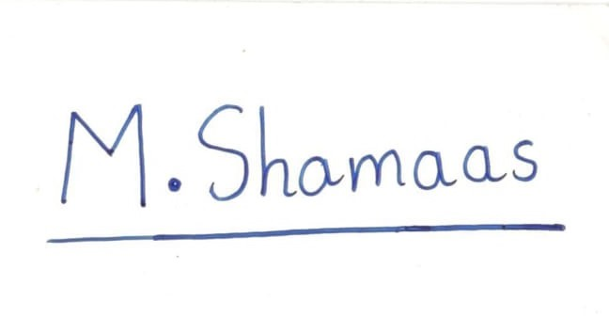

Students will not write below this line

No. __________ Dated: ______________

Approved and forwarded to the Controller of Examinations for further necessary action.

Dated: ________________ Chairman

Subject Withdrawal Policy
Regulation 12.1: Withdrawal
- This option to withdraw shall be available only to students in regular semesters other than first and second semesters.
- A student may be allowed to withdraw from a subject in which he is registered. Applications to withdraw from a subject shall be entertained latest up to the 9th study week of the semester. Withdrawn subjects shall appear in the transcript with a letter grade "W” and shall not be used in computation of GPA. In the transcript, subjects repeated after withdrawal will not be suffixed with a "R".

Regulation 12.2: Forced Withdrawal: A student registered in a subject may not be permitted to continue due to shortage of attendance or other disciplinary action. Such students shall be awarded a “WF” (Forced Withdrawal) grade. It shall appear in the transcript as such and shall not be used in computation of GPA. Subjects repeated after forced withdrawal shall not be suffixed with a “R”.

Regulation 12.3: A maximum of 32 credit hours may be allowed to be withdrawn, with a "W" grade, by a student during the entire duration of study for a B.Sc or Bachelor's degree. "WF" grade shall be counted as "W" grade for the purpose of this allowance.

Note:
1. Students withdrawing from even one subject shall not be entitled for inclusion in Dean's Honour Roll during the semester nor shall be entitled for the award of Honours degree.
2. No withdrawals are allowed during Summer semester.

